**Download and Install a copy of  
Microsoft SQL Server 2017 Express Edition**

**Recommended Download and Installation Process**

A copy of SQL Server 2017 **Express Edition** is available free of charge at

<https://www.microsoft.com/en-us/download/details.aspx?id=55994>

The Express edition is an entry-level database management system suitable for building small databases, up to 10GB. It is not as fully featured as the Enterprise Edition, or other editions in the 2017 stable, but is more than sufficient for the purposes of the module. These instructions assume you are installing on a Windows 10 machine.

1. On the landing page, click ‘Download’ and save the .exe file in your download folder - *SQLServer2017-SSEI-Expr.exe*.
2. Double click to run the .exe file and click ‘yes’ when asked if you agree to the app making changes to your device.
3. Choose the Basic installation

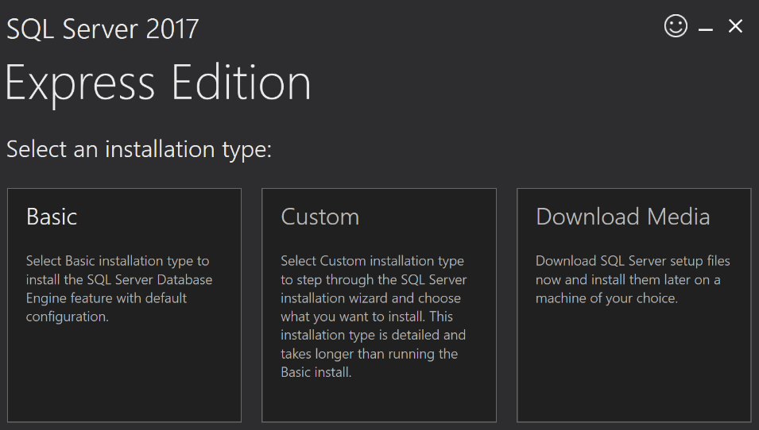

1. Click to ‘Accept’ the Software License Terms and on the following screen click ‘Install’ to install the software to the default location - *C:\Program Files\Microsoft SQL Server.*  
   You will need at least 6616 MB of free space on the C: drive for a successful installation.

The software package will automatically download and install.

You should see the following screen once the software has been successfully installed.

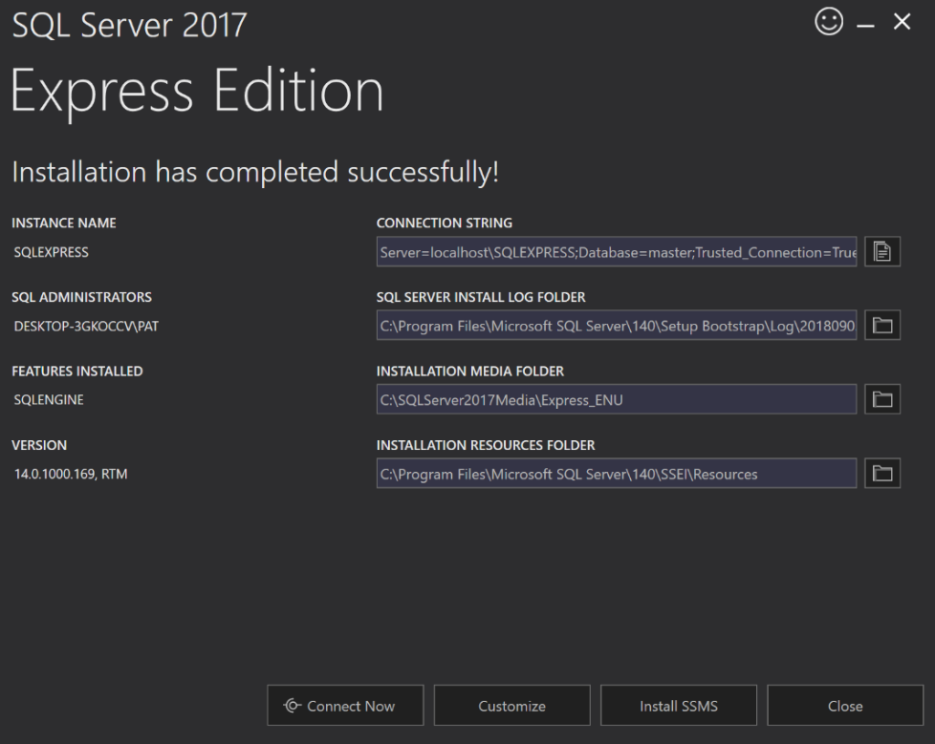

1. Click ‘Install SSMS’.

SSMS (standing for **S**QL **S**erver **M**anagement **S**tudio) is an integrated environment for managing any SQL infrastructure. During the module you will use SSMS to query, design, and manage your databases.

You will be taken to a page from which the latest version of SSMS (at time of writing - release 17.8.1) can be downloaded ( <https://docs.microsoft.com/en-us/sql/ssms/download-sql-server-management-studio-ssms?view=sql-server-2017> )

1. Locate the download link on the page and click to download the .exe file to your download folder - *SSMS-Setup-ENU.exe*
2. Double click to run the .exe file and click ‘yes’ when asked if you agree to the app making changes to your device.

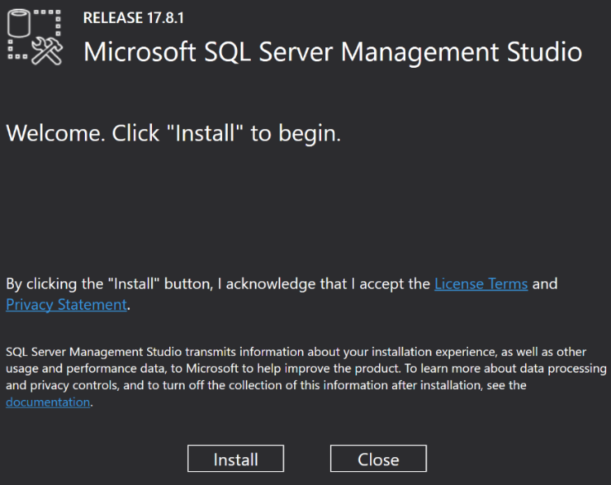

*Current version may be higher*

1. Click ‘Install’. The software will be downloaded and installed automatically.
2. Click ‘Close’ when the SSMS installation process is complete.
3. Click ‘Close’ on the Express Edition installation screen.

The installation should now be complete. You may now wish to delete the downloaded .exe files from your download folder - *SQLServer2017-SSEI-Expr.exe* and *SSMS-Setup-ENU.exe*.

**Opening SSMS (SQL Server Management Studio)**

1. 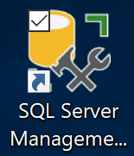Find and launch SSMS on your machine; you may want to consider pinning SSMS to the taskbar or creating a shortcut on your desktop. The SSMS icon is shown here.
2. The login screen will appear as below.

Ensure that the Server Type is set to ‘Database Engine’ and that you are using  
‘Windows Authentication’ (as opposed to ‘SQL Server Authentication’)

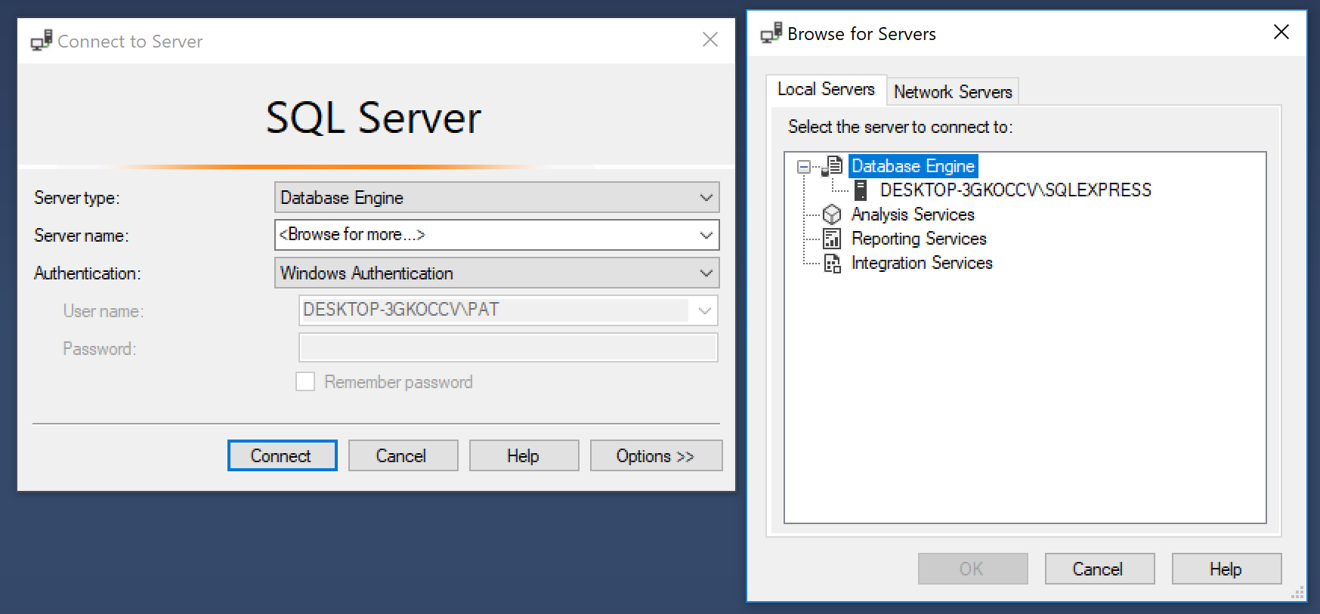

1. Select ‘Browse for more…’ under Server Name; the browsing window will appear (as above).  
   Expand ‘Database Engine’ on the ‘Local Servers’ tab, choose ‘…\SQLEXPRESS’ and click ‘OK’  
     
   (Note: - the actual name of the server on your machine may be different than that shown above, but it should end with …\SQLEXPRESS)
2. Click ‘Connect’ to open SQL Server Management Studio.

**Attaching the projemp Database (used in Lab Classes)**

The projemp database is used extensively as an exemplar during lab classes. You may find it useful to attach a copy so that you can work through the lab material on your own machine.

The projemp database is contained in the *projemp.mdf* file (all SQL Server database files have a .mdf extension). To make the database available for use, the .mdf file must reside in the **correct folder** and must be **attached** in SQL Server. You **cannot open** a .mdf file by simply double-clicking on it.

All .mdf files reside in a folder with special permissions

C:\Program Files\Microsoft SQL Server\MSSQL14.SQLEXPRESS\MSSQL\DATA

1. Download the projemp database file (*projemp.mdf*) from the Lab Resources folder on Blackboard to your download folder.
2. **Copy & Paste** *projemp.mdf* from your download folder to

C:\Program Files\Microsoft SQL Server\MSSQL14.SQLEXPRESS\MSSQL\DATA

In general, always use **‘Copy & Paste’** when moving database files - do **NOT** use **‘Drag & Drop’.**

If necessary, click ‘continue’ if you are asked for administrator permissions.

1. Open SQL Server Management Studio (SSMS) and connect to the server.
2. In Object Explorer, **right click** on Databases, and click ‘Attach…’ on the pop-up menu.

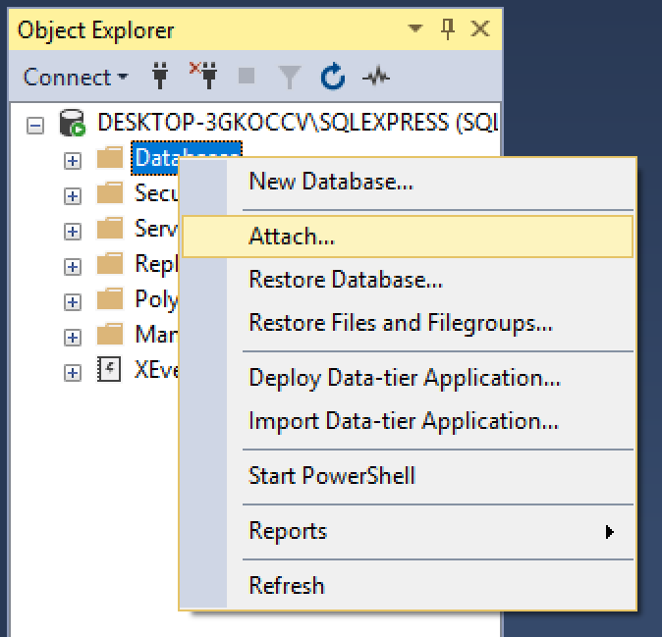

1. Click ‘Add…’ on the dialogue box, select *projemp.mdf* when the list of available databases appears, then click ‘OK’ on both dialogue boxes to attach the database.

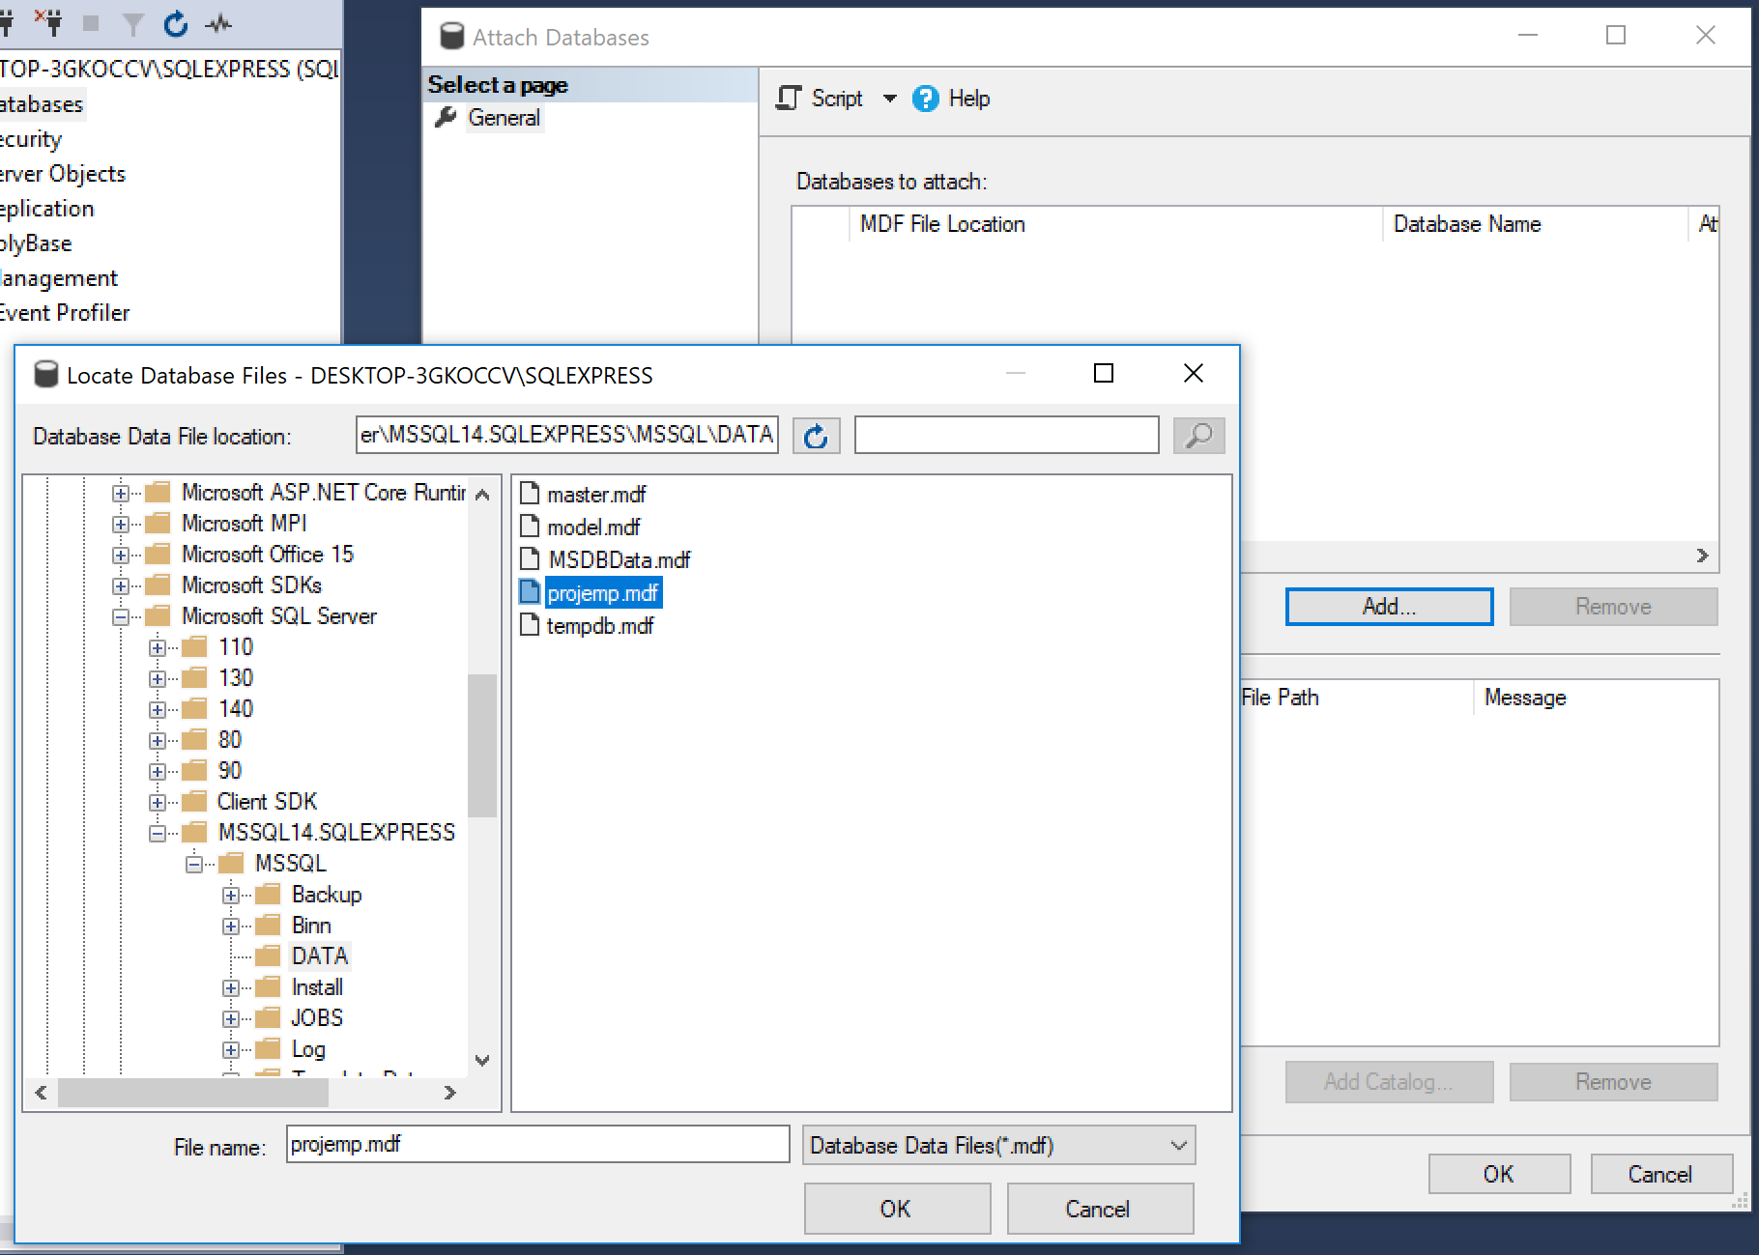

1. Expand the Databases tab in Object Explorer. projemp should now be attached and available for use.

